Perspectives of Colour
MINY'TJI [n] colour, design; paint, colouring materials (clay, ochre); [Ext] bark painting, (any) painted design (ZORC)
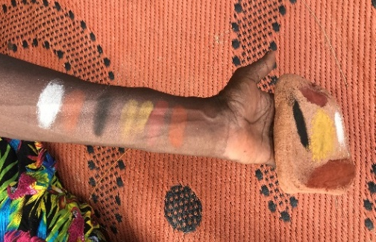
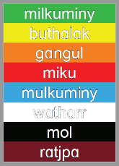
This Miny'tji Limurruŋ set of resources (2021) aims to develop a deeper understanding of the Djambarrpuyŋu dhäruk previously chosen to translate green, yellow, orange, red, blue, white, black and brown in the school setting (see left). One could never cover the depth of miny'tji in a single book, or indeed, with words on paper alone. However, these resources aim to introduce the ways in which Yolŋu understand, know and use 'colour', while prompting non-indigenous people to slow down and consider how deeply language is tied with culture.
Without attempting to change or replace the Djambarrpuyŋu dhäruk currently in use in the school, these resources aim to provide a meaningful way forward which holds respect for Yolŋu language, culture, and ways of seeing and engaging with the world.
In English, a 'colour' is an adjective and doesn't belonging to any particular group of people, but for Yolŋu, these words are physical and revered items that can be found in the land, held and used, and play an important role in Yolŋu culture, especially in art and ceremony. When asked to talk about each 'colour', Yolŋu chose to speak about where they are found, how they connect to them, and how they use them, especially relating to ceremonies, moieties and their clan-nation.
Throughout these resources, some words have not been translated, such as miku, buthalak, watharr and miny'tji, in order to form a clearer picture of what these words mean to Yolŋu, without limiting the translation to English perceptions associated with words such as 'green' and 'colour'. For example:
Mikuny dhuwal ga ratjpany rrambaŋi maṉḏa miny'tji.
Miku and ratjpa, these two are the same miny'tji. (Not: Red and brown these two are the same colour.)
Yolŋu expressed that some words need to be paired together, in particular mulkuminy and milkuminy are seen by Yolŋu to be one word and one colour, a green/blue the colour of the deep ocean. According to a large number of cross-linguistic studies, color categorical perception is tightly linked to language (Hu et al., 2019). See below for more information on how languages around the world differ in their inventory of colour words.

Watharr + Mol
Mulkuminy + Milkuminy
Miku + Ratjpa
Buthalak + Gangul

Steven Pinker: The Language Instinct
Whorf noted that we see objects in different hues, depending on the wavelengths of the light they reflect, but that physicists tell us that wavelength is a continuous dimension with nothing delineating red, yellow, green, blue, and so on. Languages differ in their inventory of color words: Latin lacks generic "gray" and "brown"; Navajo collapses blue and green into one word; Russian has distinct words for dark blue and sky blue; Shona speakers use one word for the yellower greens and the greener yellows, and a different one for the bluer greens and the nonpurplish blues. It is language that puts the frets in the spectrum. Where languages do differ in their color words, they differ predictably. Languages are organized a bit like the Crayola product line, the fancier ones adding colors to the more basic ones. If a language has only two color words, they are for black and white (usually encompassing dark and light, respectively). If it has three, they are for black, white, and red; if four, black, white, red, and either yellow or green. Five adds in both yellow and green; six, blue; seven, brown; more than seven, purple, pink, orange, or gray. But the clinching experiment was carried out in the New Guinea highlands with the Grand Valley Dani, a people speaking one of the black-and-white languages. The psychologist Eleanor Rosch found that the Dani were quicker at learning a new color category that was based on fire-engine red than a category based on an off-red. The way we see colors determines how we learn words for them, not vice versa.

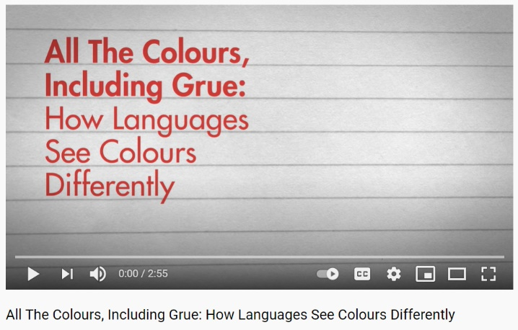
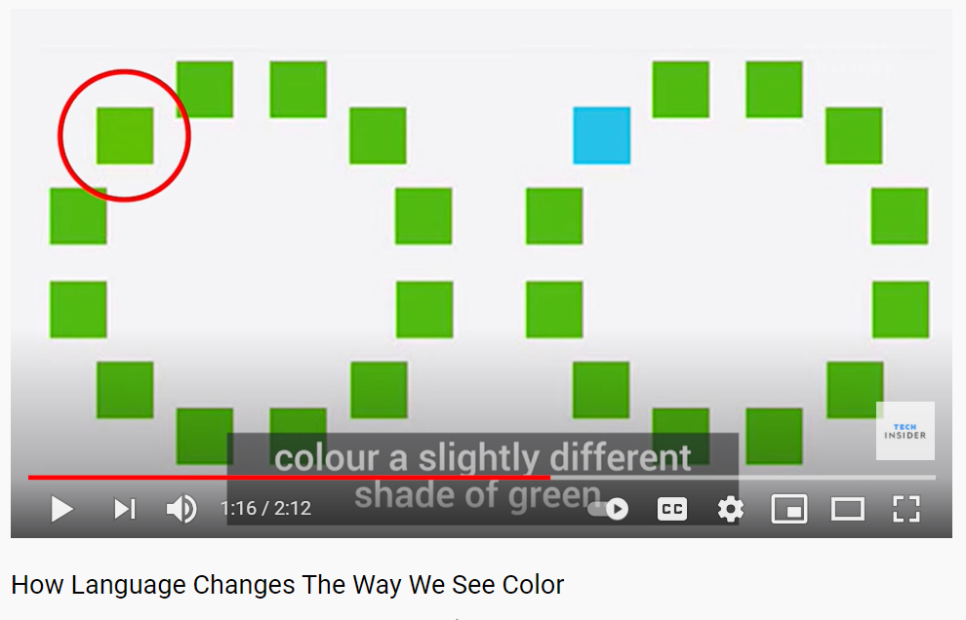https://www.youtube.com/watch?v=mgxyfqHRPoE https://www.youtube.com/watch?v=2TtnD4jmCDQ
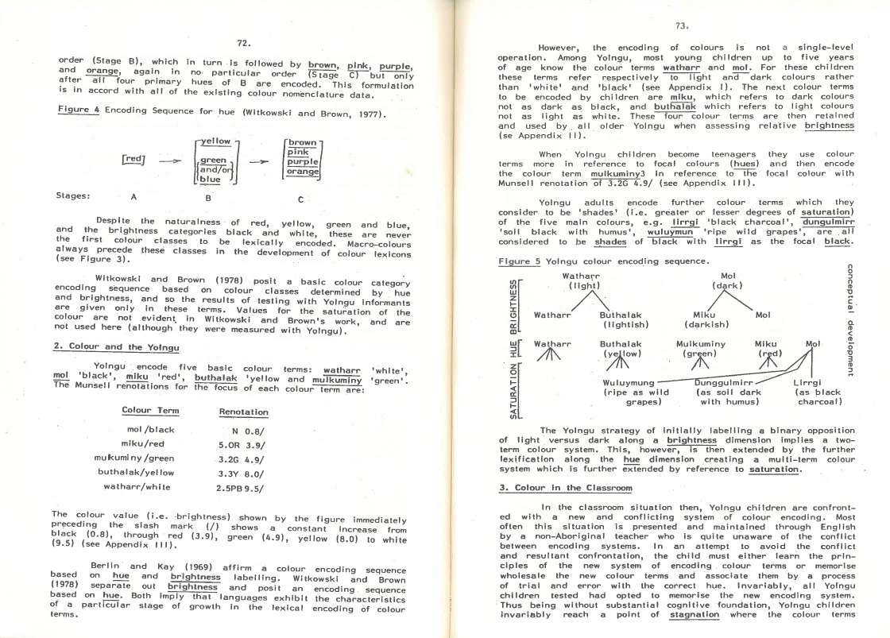
A study by Davis (1982), conducted with Yolŋu at Milingimbi, found that in contrast to the system of colour encoding in English, which is based on the differentiation of hues, Yolngu people seem to encode colour terms by the brightness contrast. The colours are thus considered in terms of their degree of saturation compared to black and white. For example, yellow is not as light as white, and green is not as dark as black. Davis posits that colour terms mol ‘black’ and watharr 'white' are the first colour terms to be acquired by the Yolngu children.
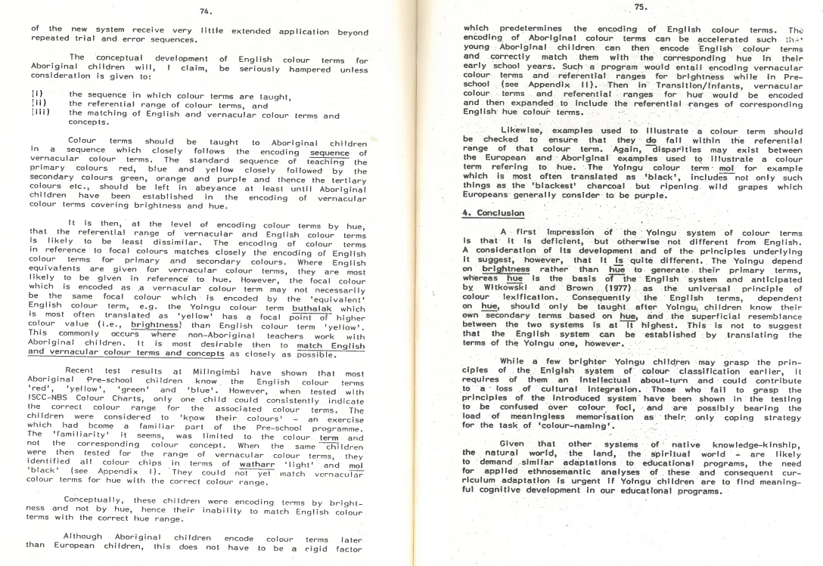

References:
Adone, D., Bauer, A., Cumberbatch, K., & Maypilama, E. L., (2012). Colour signs in two indigenous sign languages. 55-86. 10.1515/9781614511496.53
Davis, S. (1982) Colour Classification and the Aboriginal Classroom. In Garner, M., (Ed.), Applications of Linguistics to Australian Aboriginal Contexts. (pp. 68-79) Applied Linguistics Association of Australia.
Hu, H., Jie, L., Qianguo, X., Songxiu, J., Yisheng, Y., & Sheng, Z., (2019). Language and Color Perception: Evidence from Mongolian and Chinese Speakers. Frontiers in Psychology, 10, 2019 https://www.frontiersin.org/article/10.3389/fpsyg.2019.00551
Pinker, S. (1994) The Language Instinct: The new science of language and mind. London: Allen Lane, the Penguin Press.

